260 Ecological responsibility and sustainable development

Impact of building materials choice on the environment

Maria Sinara Alves de Lacerda, Patrick Vinicius Fonseca da Silva and Carla Matheus

1. Introduction
Building, expanding is a must, but as any basic act it is necessary to take into account its impacts. In a world where every year the population and its needs increase, it is essential to have an initiative or action plan to stop or minimize the impacts caused in this process. Taking into account a few points, in 2015 world leaders gathered at UN headquarters in New York and decided on an action plan to eradicate poverty, protect the planet and ensure that people achieve peace and prosperity. This plan was named Agenda 2030, the set of 17 sustainable development goals (SDG). These tasks propose t sustainable paths and measures of transformation to the world (United Nations, 2015). Sustainability is a prominent topic at the moment, and according to the Brundland report (1987) from United Nations (UN) it is defined as: “Sustainable development is development that meets the needs of the present without compromising the ability of future generations to meet their own needs.” (WCED, 1991, p. 46)
According to Tajiri et al (2011), the government must act to reach sustainable development, however there are great obstacles to achieve this goal, such as the lack of governmental incentives and the resistance to changes in attitude.
The critically effects caused by predatory exploration of ecosystems may be evidenced by a study published by the Met Office Hadley Centre for Climate Change, which presents data on the anomalies of the average temperature of the earth through time, where it is possible to observe a clear rise in temperature after the industrial revolution. Data from the 2013 Intergovernmental Panel on Climate Change (IPCC) report also confirm this information with databases other than HadCRUT4 and project a rise in average anomalous temperature from 0,3ºC to 0,7ºC (IPCC, 2018).
The climate changes and other environmental aspects of the present demonstrate the need to widely discuss the ecological responsibility in the different social aspects in the quest of sustainable development. In this bond, it is worth mentioning that the civil construction occupies a central and unique role in this scenario, as it is a major resources consumer and waste producer.
In Brazil, there is an institution that regiments the materials or the conditions they have to present in order to be used in civil construction, it is named Associação Brasileira de Normas e Técnicas (ABNT) and will be constantly mentioned in this article, and used to approach the impacts of three types of materials used in Brazil for sealing, which are: Solid Brick obtained from clay and thereafter shaped and burned, NBR 7170/; Concrete block made of Portland cement, water and aggregate materials such as blast furnace slag, fly ash or expanded clay governed by NBR 6136/2006 and Compressed Earth Block which raw materials are water, Portland cement and soil with the possibility of using additives, NBR 8491/2012.
Given the above, the present study explains the sealing materials with the objective of analyzing and comparing them with each other, so that the effects associated with the use of each material and, consequently, its positive or negative participation for sustainability are clear , focusing on the most used and also some of the most promising in Brazil, analyzing the origin, possibility of reuse and disposal. Therefore, this study seeks a greater comprehension about how civil construction relates to sustainability when evaluating the main materials and their environmental impacts.

2. Origin of the sealing materials used in the Brazilian civil construction
The human being's need to protect spaces, seek shelter to protect himself from the intemperate nature and survive goes back to prehistory. The security of housing only became possible from the moment the human being began to settle in their own house, land and family. Made from reddish clay, the solid bricks are widely used in the manufacturing of walls inside the civil construction, in large scale. The earliest traces of bricks date from 7,500 BC. At first, they were not baked, only dried in the sun. Around 3,000 BC the baked bricks began to appear, much more resistant. The exact time and origin are unknown, possibly the Romans were the firsts to use the product the way we know it today, because they dominated the clay burning process. The solid brick (figure 1) began to be used when the natural stone became limited. The brick arrived in Brazil around the 19th century by the hands of italian immigration, which began masonry housing in São Paulo (Fac - Arquitectura de Lisboa, 2007).

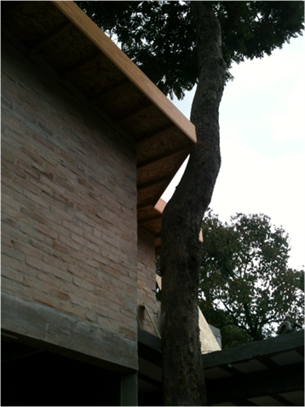
Fig.1 Residence built with solid brick. Source: The authors (2017)

The manufacturing of solid bricks begins in deposits or barriers, almost always at margins of rivers, where the clay is extracted. There are several types of clay that give different properties to the bricks. It is common to add other materials to clay in order to give the raw material the desired characteristics. It goes through quality control to ensure its characteristics. Some factories use mining waste in their preparation (waste that would be discarded in landfills or would have an inappropriate end), contributing to the environment, and improving the mass. Then, the mass goes through a process called extrusion, and then it goes drying. The drying process can be performed naturally or forced, artificial or mixed. Finally, in the burning process the blocks are taken to furnaces where the temperature varies from 750ºC to 1000ºC.

These furnaces can be fed by wood or sugarcane bagasse. The solid bricks go through a compression test in accordance with NBR 6460. The visual, geometric and mechanical characteristics must comply with the standard NBR 7170. Products within the standards are approved by the National Institute of Metrology, Quality and Technology (Inmetro ) (Sebrae, 2018).
The solid brick is one of the most used in Brazilian civil construction. For this reason, studies have been carried out to ascertain its impact on the environment. In addition to its raw material being a non-renewable material, which already brings great impact to nature, the emissions of gases in its manufacture is significant. If the Global Warming Potential (GWP) is evaluated by the IPCC method for a period of 100 years, the CO2 emission presents significant values with a total of 0.6219 kg of CO2 for each kilo of brick produced. According to the graph below, most of the CO2 is released by transporting the clay to the pottery and transporting the brick from the pottery to the consumer, due to the burning of diesel oil (Barbosa et al, 2012).

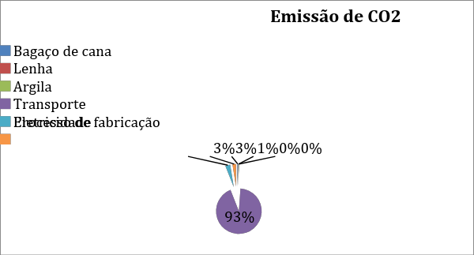
Fig.2 Impact contribution from CO2 Emission: IPCC Method 100 years
Source: The authors, based on Barbosa et al (2012)

Thus, this material ends up not being a sustainable option, since it is a great polluter throughout its life cycle, especially in its conception, which does not fit the perspective of the sustainable housing, which according to Tajiri et al (2011) , seek for environmental adequacy, economic viability and social justice.
Still considering the emission of CO2, most of it is released by transporting the clay to the pottery and transporting the bricks from the pottery to the final consumer due to the burning of diesel oil. Burning fossil fuels in internal combustion engines is one of the main sources of increased concentrations of greenhouse gases (GHGs) and rising global temperatures. The life cycle of fossil fuels is considered an energy system, its activities of extraction, transportation, processing, distribution and final use can cause significant environmental impacts (Barbosa et al, 2012).
Concrete blocks (Figure 3) for masonry emerged in the twentieth century as an alternative material in civil construction, replacing the solid brick, which is handcrafted till this day. Beginning in the 1960s, its consumption and acceptance was really quick, since it represents the best option in several situations (SEBRAE, 2018). According to the norm NBR 6136 the block is defined as a masonry element which net area is equal to or less than 75% of the gross area. The concrete block is used on a large scale in Brazil. It was the first block to have a Brazilian standard for structural masonry calculation. It has good compressive strength and the production range is between the minimum 4.5 MPa required by the standards and 16 MPa. The walls constructed with concrete blocks perform the functions of structure and closing, eliminating pillars and beams and reducing the use of armor and forms. There is a complete set of ABNT standards for the quality of materials and the structural masonry system with concrete blocks. Among them there are NBR 15873/2010 - Modular Coordination for Building, NBR 6136/2008 - Hollow Concrete Block for Concrete Masonry - Requirements, NBR 10837: 89 - Structural Masonry Calculation of Hollow Concrete Blocks (Sahara, 2017).

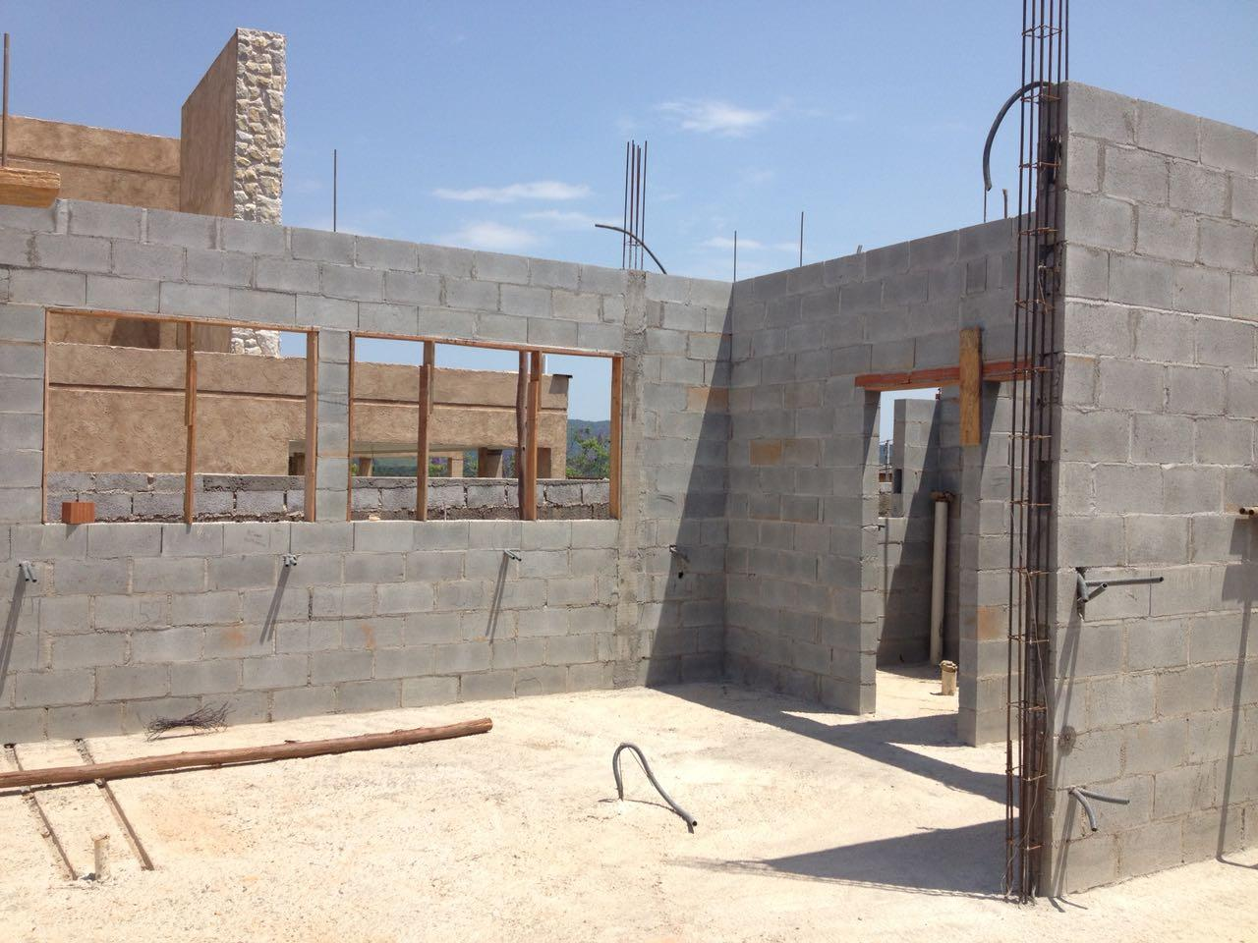
Fig. 3 Residence built in concrete block. Source: The authors (2018)

Currently there are several types of blocks for different applications. These blocks are produced in factories that use all types of processes, ranging from small craft presses to huge, fully automated industrial assemblies. They are made with a pressed mixture of cement and an aggregate. This aggregate can be sand, pebbles, stone powder or similars. It is common to use a mixture of two or three types of aggregates, to improve the quality and cost of the block. The choice of aggregates also depends on their supply nearby the plant (SEBRAE, 2018).
As already mentioned, the transportation of the raw material and the final material to its destination is one of the greatest contributors to air pollution, due to the emission of CO2, by burning the fuels used in the trucks. But there are also stationary sources like factory chimneys, construction sites and mining activities. Besides to these gaseous pollutants resulting from these activities, there is dust, which is a particulate matter and is considered a primary pollutant, it means this pollutant is emitted directly into the atmosphere from identifiable sources (SINGH, 2006). Concerning to air pollution, Brazilian legislation obeys several resolutions, and laws, with emphasis on Resolution CONAMA n. 5 (1989). This Resolution certifies the National Air Pollution Control Program - PRONAR, which aims at improving air quality, meeting established standards and not compromising air quality in areas considered undegraded (CONAMA, 2012).

As other economic activities, the production of blocks results in the generation of large amounts of dust. There are two types of dust, the suspended one formed by particles smaller than 10μm, which tend to remain in the air for a longer time, and the sedimentable dust, consisting of fractions larger than 10μm, which tend to sediment, remaining for less time in the air. However, it is important to note that even sedimentable dust can become suspended dust, depending on the conditions. In drier weather conditions, the dust tends to be in suspension. The same happens when there is constant disturbance of the soil where it is deposited. In concrete block factories, this dust tends to deposit mainly in the yard, where there is a large flow of vehicles that promote the resuspension of the particulate materials. In addition to dust, the production of concrete blocks generates solid waste, such as defective products, waste of products used in tests or waste generated during the production process itself. As already mentioned, the production process of the blocks requires the molded material to be placed in a greenhouse at 75ºC, the heating of the greenhouses is given by the operation of diesel-powered boilers, which can cause leaks and oil infiltration into the soil (Guzzo , 2014).
Therefore, due to its great economic viability, this material ends up being largely chosen, as Motta (2014) corroborates, mainly due to its fast masonry execution. However, although it is more correct than solid brick, it is still not the best sustainable option due to its high GHG emission.

The Compressed Earth Block (CEB) (Figure 4) is also known by the technical names of modular or ecological block. It is a brick produced from a mixture of earth, cement and water. The soil used is sandy, widely found in our region. The soil should not contain organic matter. It is also possible to use the ground residue of building material in its composition (Pinatti, 2004).

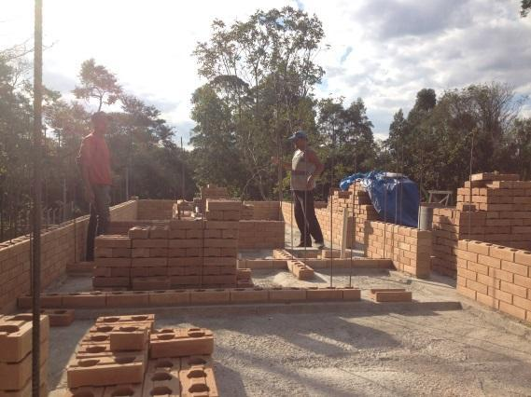

Fig. 4 Use of compressed earth block. Source: The authors (2017)

The CEB is conformed in hydraulic press, giving to the ecological brick its form. After the conformation, the organic brick remains moist for several days, so that the soil-cement cure occurs, with the consequent hardening of the brick. The main difference in relation to others is the hydraulic curing: the product is not baked in the furnace- a process that consumes wood and still results in the emission of polluting gases. Other characteristics that make it environmentally friendly are the proportion of cement incorporated into the mass (about 10%) and the type of soil used. It is a sandy soil and, since it has no hail, it can be removed from nearly all areas, not restricted to areas of permanent preservation, such as sedimentary clay which sources are located near springs (Pinatti, 2004). Bricklaying can be accomplished by simply fitting the pieces, without the need for mortar. The builder must always be aware of the alignment of the brick strings and the plumbing of the masonry.
The CEB is normalized by the quality standard of ABNT NBR 8492/2012 (ABNT, 2018). In Brazil it was first used in the production of bases and sub-bases of road pavement. CEB began to be used in construction in 1948, when residences made with monolithic walls were built at Fazenda Inglesa, in Petrópolis, RJ, Brazil. A year later, the famous Hospital Adriano Jorge, of the National Tuberculosis Service, was built in Manaus, a 10,800 m² building still in operation and in good repair. (Téchne, 2004).
However, CEB was only widely applied in housing around 1978, when the former National Bank of Housing approved the technique for constructions of popular housing. Studies carried out by the Instituto de Pesquisas Tecnológicas de São Paulo (IPT) and the Centro de Pesquisas e Desenvolvimento (Ceped) have shown that, in addition to the good acoustic performance, the CEB applied in constructions led to a reduction of costs of 20 % to 40%, compared to traditional masonry of clay or ceramic bricks (Teixeira, 2004).
The masonry made with CEB offers some advantages: it eliminates the coating, mortar of settlement, besides not requiring wood burning or fuel oil for its production, which reduces costs of the construction. As the monolithic wall, CEB is usually manufactured with the site's own soil, which reduces costs related to the raw material and its transport (Téchne, 2004).
As a disadvantage of this system, there is a possible dependence on manual and hydraulic presses which values are high (Téchne, 2004) and the fact that the technical standards of ABNT, which determine characteristics such as shape, dimensions, compressive strength and water absorption of compressed earth blocks, disregard the application of the pieces in structural masonry.

In view of the above, between the 3 materials analyzed, it can be said that compressed earth block is the most suitable for sustainable development objectives, considering its characteristics that may indicate a more balanced alternative considering the economic and environmental aspects. In addition, this material has the possibility of being used in many places due to its simplicity regarding the raw material.

3. Waste generation and disposal of masonry materials mostly used in Brazil

According to the National Association of Bioecological Architecture, civil construction in Brazil is responsible for consuming 40% of natural resources and energy, 34% of water consumption, 55% of uncertified wood consumption, 67% of the total mass of urban solid waste and 50% of the total volume of waste comes from construction (Chaves, 2014). These figures are too large and are not aligned with the objectives of Agenda 30 for sustainability, especially regarding objectives 8, 9, 11, 12, 13 and 15, which seek to:

Objective 8. Promote sustained, inclusive and sustainable economic growth, full and productive employment and decent work for all;
Objective 9. Build resilient infrastructure, promote inclusive and sustainable industrialization and foster innovation;
Objective 11. Make cities and human settlements inclusive, safe, resilient and sustainable;
Objective 12. Ensure sustainable consumption and production patternss
Objective 13. Take urgent action to combat climate change and its impacts;
Objective 15.Protect, restore and promote sustainable use of terrestrial ecosystems, sustainably manage forests, combat desertification, and halt and reverse land degradation and halt biodiversity loss (United Nations, 2015, p 14)

In this sense it is worth mentioning ISO 14000 which is a set of norms that focuses on environmental management. Some of these standards deal with Life Cycle Assessment (LCA), a procedure which purpose is to evaluate the environmental impacts of a product or material from its acquisition to its final disposal (ABNT, 2015).
Thus, it requires special attention when building, considering the design of the project, the production of materials and the resources involved. It is necessary to look for a production cycle which minimizes the exit of output and input of raw material, it is up to the technical responsible to select situations and materials that have less impact.
The concern about the disposal and reuse of waste is something new in Brazil compared to other countries like USA, which since has policies on waste since the 1960s and Europe that began practicing after the Second War (John, 2000).
According to the Associação Brasileira de Empresas de Limpeza Pública e Resíduos Especiais (ABRELPE), Waste from Construction and Demolition (WCD) in Brazil is destined, almost exclusively, to landfills and street maintenance. This reality indicates a poor management of these materials, that is, economic waste of recyclable materials. In addition, it is evident that there is not a correct destination or an efficient reuse of the materials used in construction sites (ABELPRE, 2016).
Brazilian municipalities collected about 45.1 million tons of WCD in 2016, a decrease of 0.08% compared to 2015. This situation, also observed in previous years, requires special attention, once the total quantity of these wastes is even greater, since municipalities, as a rule, collect only the waste dumped or abandoned in public places. When thinking about the share of individual responsibility of the citizen, this percentage is equivalent to 123.219 tons / day or 0.600 kg / inhabitants / day.
From the environmental point of view, the main problem with this type of waste is related to its irregular deposition and the large volumes produced. These irregularly deposited residues cause flooding, proliferation of vectors that are harmful to health, partial interdiction of roads and degradation of the urban environment. These residues are often accepted by real estate owners who use them as a landfill, usually without major concerns with the technical control of the process. This practice can lead to future construction problems.
In addition to the consequences mentioned above, the removal of irregularly accumulated waste costs to the public safes. In São Paulo alone, almost 3,000 tons of rubble are daily removed from the streets at a cost of R $ 50 million per year (G1, 2011)
In the light of the above, changes are necessary so that the production of rubble can be minimized. These changes need to be reviewed in the three main stages of rubble generation: construction (construction site); maintenance and reform; demolition. The generation of the waste during the construction phase is due to the losses of the construction processes, mortar and concretes made in larger quantities. Changes are important to reduce construction losses and rubble. Processes such as the incorporation of facilities in masonry walls that require the partial breaking of the newly constructed wall and its reconstruction with mortar must be abandoned. But not all new technologies have recently been used to reduce losses. This is the case of internal gypsum-based coatings, with losses of up to 120% in service. The reduction of losses generated in the construction phase has a direct impact on the reduction of the amount of material incorporated in the works, which results in the reduction of waste in the maintenance and demolition phases (John, 2000).
In the maintenance phase, the generation of rubble results from facts such as: correction of defects (pathologies); remodeling or modernization, which usually require partial demolitions; disposal of components that have degraded and reached the end of their useful life and therefore need to be replaced. In Brazil, in general, the projects do not even consider the existence of maintenance activities and their costs. Currently, the industry concentrates a lot of effort on quality management programs. The other measures to reduce waste at this stage depend on the awareness of members of the construction chain, which will only be obtained in the long term. Flexible projects rely on new technologies, which are coming to the country. These new technologies allow dismantling with reuse of some of the components (John, 2000).
The reduction of waste caused by demolition depends on: the extension of the useful life and its components, which depends on both design technology and materials; the existence of incentives for owners to carry out modernization and not demolitions; of design technology and demolition or disassembly that allows the reuse of components (John, 2000).
National waste recycling experiments in the form of aggregates are used in paving works and in the production of small concrete components such as paving blocks. The reduction of the generation of this residue is complex, and can only be reached in medium or long term. Recycling of construction and demolition waste is technically and environmentally feasible. The risk of environmental contamination by this type of recycling can be considered low, although minimal control is desirable especially when dealing with wastes from industrial plants.

4. Final considerations

The development of this study was based on the comparison of the three main types of bricks and blocks most used in Brazil and the analysis of their environmental impacts, atmospheric emissions and the production process. Among all the categories analyzed, the transportation of the raw material for the production of bricks and blocks and the transportation of ready-made items most contributed to the potential environmental impacts, with diesel oil being the most commonly found substance in the impacts of the analyzed categories.
The burning of fossil fuels in internal combustion engines is one of the main sources of increased greenhouse gas (GHG) concentration and the average temperature rise of the planet. The life cycle of fossil fuels is considered an energy system. Its extraction, transportation, processing, distribution and final-use activities can cause significant environmental impacts.
Considering the emission factors of pollutants the substance emitted in greater quantity was the carbon dioxide (CO2). Note this being consonant with IPCC data, where CO2 gas is the main contributor to a radiative forcing increase, with 80% of the total increase, where increasing radiative forcing is related to atmospheric warming. It is possible to point out that in order to minimize the negative impacts of civil construction on the environment, it is necessary to replace traditional construction techniques with other more efficient ones, being indispensable to the search for alternatives for greater rationalization and modulation.
Considering the perspective of the Brundtland report for sustainability and according to this study, it is clear that the construction industry is largely responsible for the great distance from the point of balance in terms of environment, economy and society. This contribution to the unbalance is evidenced in the data collected by ANAB, which shows, as previously mentioned, that civil construction consumes a lot of resources and generates a lot of waste.
Thus, in order to achieve sustainable development, it is necessary to abandon the old ideas that the planet will always replace what the human being extracts and absorb the generated waste. It is necessary to adopt techniques, materials and logistics that are more efficient and environmentally responsible.

Referências Colocar nas normas da editora

Associação Brasileira de Empresas de Limpeza Pública e Resíduos Especiais (2016) Panorama dos resíduos sólidos no Brasil 2006 Abrelpe, São Paulo http://www.abrelpe.org.br/Panorama/panorama2016.pdf Acessed 3 Apr 2018

Associação brasileira de normas técnicas. NBR ISO 14.040. Gestão ambiental – análise do ciclo de vida – princípios e estruturas. Ano da norma

Associação brasileira de normas técnicas. NBR 8491:2012. Tijolo de solo-cimento – Requisitos

Associação brasileira de normas técnicas. NBR 10833:2012 Versão corrigida 2013. Fabricação de tijolo e bloco de solo-cimento com utilização de prensa manual ou hidráulica – Procedimento

Associação brasileira de normas técnicas (2015) NBR ISO 14001:2015. Sistemas de Gestão Ambientai. Requisitos e Orientações para Uso. ABTN, Rio de Janeiro

Barbosa, P. P.; Silva, T. L.; galassi, C.; Luz, S.; Neto, G. A. SIMPGEU. Análise dos impactos ambientais da produção de blocos cerâmicos. III Simpósio de Pós-Graduação em Engenharia Urbana, 2012.

Catálogo de normas da abnt: Disponível em <http://www.abntcatalogo.com.br>. Acesso em 13 Março 2018.

Colin P. M. et al. Quantifying uncertainties in global and regional temperature change using an ensemble of observational estimates: the HadCRUT4 data set. Ano? É um artigo de revista?

CONAMA – Conselho Nacional do Meio Ambiente (Brasil). Resoluções do Conama: Dispõe sobre o Programa Nacional de Controle da Poluição do Ar – PRONAR < http://www.mma.gov.br/port/conama/legiabre.cfm?codlegi=81 >.13 janeiro 2018. Ano?

Fac Arquitectura de Lisboa - 0 tijolo e a sua aplicação ao longo do tempo, 2007. Disponível em: http://home.fa.utl.pt/~lcaldas/Tijolo.pdf Acesso em: 10 Março 2018

IPCC, http:// www.ipcc.ch> acesso em 06 janeiro 2018.

John. V.M.; agopyan. V. Reciclagem de Resíduos da Construção. Seminário – Reciclagem de Resíduos Sólidos Domiciliares, São Paulo, 2000.

Jornal Nacional. Reportagem - Prefeitura de SP gasta R$ 50 milhões por ano para dar destino a entulho. Disponível em : <http://g1.globo.com/jornal-nacional/noticia/2011/01/prefeitura-de-sp-gasta-r-50-milhoes-por-ano-para-dar-destino-ao-entulho.html> Acessado em: 15 Março 2018

Chaves, H. O; Poli monografias – Diretrizes sustentáveis na construção civil, 2014. Disponível em <monografias.poli.ufrj.br/monografias/monopoli10011743.pdf> Acesso em 13 Março 2018

Deigo, V.H; Costa, W.A.S; Araujo, R.C; Silva, M.P: Augusto Guzzo Revista Acadêmica - Problemas E Soluções Ambientais Causados Por Uma Empresa De Produção De Blocos De Grande Porte, 2014, N°13, Disponível em: <http://www.fics.edu.br/index.php/augusto_guzzo/article/view/229> Acessado em 13 Março 2018

Sahara, <http://www.sahara.com.br/artefatos-vibro-moldado/blocos-de- concreto.php > 06 janeiro 2018.

SEBRAE. Fabrica de tijolos de concreto. Disponível em: < http://www.sebrae.com.br/sites/PortalSebrae/ideias/como-montar-uma-fabrica-de-tijolo-de-concreto,a7e87a51b9105410VgnVCM1000003b74010aRCRD> Acesso em ; 10 Março 2018

SEBRAE. Olaria, fabricação de tijolos. Disponível em: <http://www.sebrae.com.br/sites/PortalSebrae/ideias/como-montar-uma-olaria-para-a-fabricacao-de-tijolos,e6e87a51b9105410VgnVCM1000003b74010aRCRD> Acesso em: 10 mar. 2018

Singh, Y. K. Environmental science. New Delhi: New Age International Publishers, 2006. Disponível em: <http://depositfiles.org/files/3bfd4zo16>. Acesso em: 19 dez. 2018.

Taveira, E. S. N. O Solo Cimento no Campo e na Cidade – Construir, Morar, Habitar. 2 ed. São Paulo: Cone, 1987.

Téchne. Alvenaria de solo cimento. Téchne a revista do engenheiro civil. Nº 85. Ed. São Paulo: PINI, 2004.

Téchne. Blocos cerâmicos: Leveza e desempenho. Téchne a revista do engenheiro civil. Nº 239. p 16. Ed. São Paulo: PINI, 2017.

Tajiri, CAH, Cavalcanti, DC, Potenza, J L (2011) Habitação Sustentável, Secretaria do Meio Ambiente Coordenadoria de Planejamento Ambiental, São Paulo

United Nations (2015), The 2030 agenda for sustainable development. https://sustainabledevelopment.un.org/content/documents/21252030%20Agenda%20for%20Sustainable%20Development%20web.pdf Accessed 20 Jan 2017.

Comissão Mundial sobre Meio Ambiente (1991) Nosso Futuro Comum. Fundação Getúlio Vargas, Rio de Janeiro

